**Baylor Fiber Study**

Dear Study Participant 1008,

We appreciate your time and participation in this important study. As part of this study we will be collecting information on your diet 3 times using 2 different online tools. **Prior to beginning the supplement intervention and prior to providing the first stool sample**, please complete 2 diet assessments found online – DHQ3 and ASA24. The instructions for completing these two diet assessments are below. One is called an ASA24 and the other is called the Food Frequency Questionnaire that has an abbreviation of DHQ3. When you complete WEEK 12 of the supplement intervention, we want you to complete ONLY the ASA24 again, within 24 hours of providing the second stool sample. In total, for this study, you will need to complete 3 dietary assessments.

The dietary assessments can be completed from any computer in 30min to 1hr. However, **the ASA24 assessments need to be completed within 24 hours of producing your stool sample for collection**. This information is very important for the study. The diet assessments will provide important information to the researchers to help us understand how your diet is associated with the bacteria that live in your gut, and how diet impacts your response to the supplement.

**Please follow the directions below for the completing the ASA24 and DHQ3.**

**________________________________________________________________________**

**Study participant’s instructions for accessing and completing dietary recall online:**

ASA24 Instructions

1. Make sure you use a computer that has an Internet browser that has either Internet Explorer, Firefox, or Safari.
2. Type in the following URL (web address) to your computer’s Internet browser:

🡪 [**https://asa24.nci.nih.gov/Login.aspx**](https://asa24.nci.nih.gov/Login.aspx) **(or https://asa24.nci.nih.gov)**

1. Once you have opened the “ASA24” website, you will see the homepage and will be asked to enter your Username and Password: **You will find your ASA24 username and password in your Fiber Study ID email.**
   * NOTE: You will use a same username and password each time you complete the ASA24.
   * **If your browser asks to “save password” when you enter your username and password, please select “NO”.**

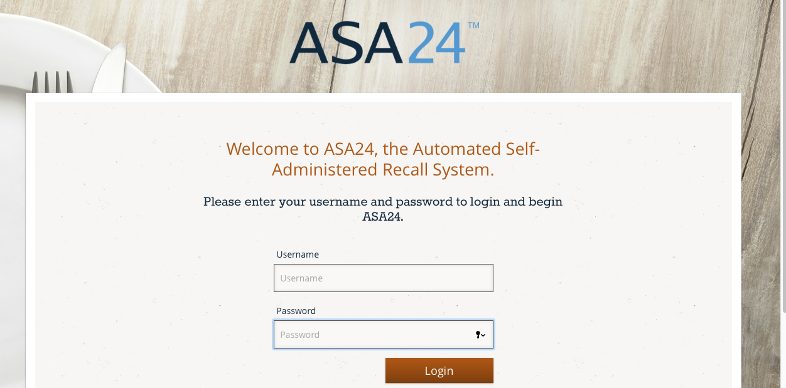

1. After putting in your username and password, click the red login tab. This should bring up another screen. Please follow the directions on the screen.
2. The next screen will ask you to report what period of time you are reporting. Please choose “Yesterday” to report everything you ate or drank yesterday from midnight to midnight.
3. Choose “next”
4. The next screen will ask you if you speak English or Spanish.
5. A welcome page will appear next. After you read the welcome instructions, look at the bottom right corner and click on the button that says, “report a meal”. A box will appear with instructions on how to report meals and snacks. Once you finish reading click “ok”.
6. On the next window, select the FIRST food, drink or meal you had yesterday.
7. THEN continue following the instructions until you have reported all of the items consumed from yesterday.
8. PLEASE do not stop until you complete the entire assessment.

**DHQ-III (FFQ) Instructions**

1. This online assessment tool will take you **about 30 minutes to 1hr** to complete. Be sure you are away from distractions and allow adequate time to answer the questions.
2. Type in the following URL (web address) to your computer’s Internet browser:

🡪 [**https://www.dhq3.org/respondent-login/**](https://www.dhq3.org/respondent-login/) **(type in your username and**

**password provided in your Fiber Study ID email)**

**OR paste in your personal study URL login (found on your Fiber Study ID email)**

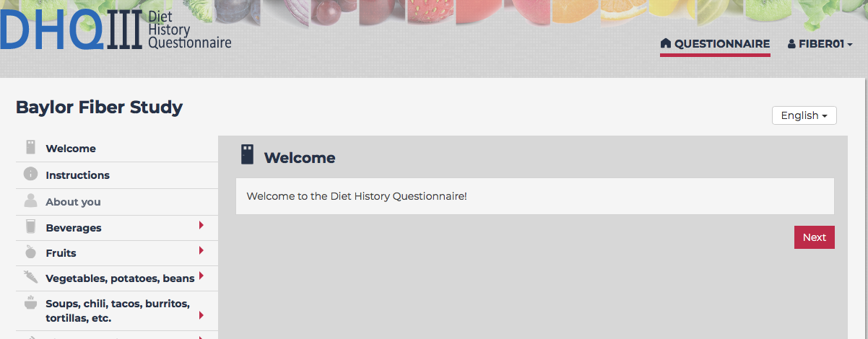

1. Once you have successfully logged into the website please follow the directions prompted by the screen.
2. THEN you will start the dietary assessment of your **eating habits over the past month**.
3. PLEASE do not stop until you complete the entire assessment.

**Your ASA24 ID and Password:**

|  |  |
| --- | --- |
| BFiber1008 | Fiber!249 |

**Your DHQ3 ID and Password:**

|  |  |
| --- | --- |
| Fiber08 | RVrjgjJP |

**Your DHQ3 URL:** <http://www.dhq3.org/respondent-login/?uuid=dec22432-95cc-449a-b9b2-a578b4401e97>